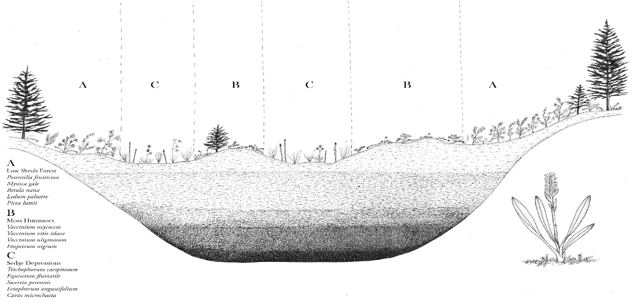
Representative peatland cross section showing depth and plant community distribution and species list (art by Conrad Field)

