Stariski Creek Meadows
Field-Based Learning Location
Location: Anchor Point, Alaska
Lat Long: 59.897439, -151.716396 KPB PARCEL ID: 15914045
T 3S R 14W SEC 20 SEWARD MERIDIAN HM 0970062 STARISKI MEADOWS LOT 20
Physical Site Description: Fen-type freshwater wetland with a headwaters stream. No restrooms or facilities of any kind. Mosquitoes and flies were abundant in June/July 2019; bug dope and baggy, full-coverage clothing recommended.

Optimal Dates: May to September, or whenever snow is not present
Potential number of participants: optimal amount is 30 or less

Land Ownership:
Meadow Property: Owned by Kachemak Heritage Land Trust (KHLT)
Contact: Marie McCarty (Executive Director), Marie@KachemakLandTrust.org
Joel Cooper (Stewardship Director), Joel@KachemakLandTrust.org
Creek Property: Owned by Kachemak Heritage Land Trust (KHLT)
**If using the bridge and creek- allowed on the side closest to the main road.

Travel Logistics:
Turn on Resch Ave from Sterling Highway North of Anchor Point, AK. Travel is on a dirt road and crosses a single-car bridge. Right on Cloyds Rd, Left on Sergeant Ave, Left on Pepper St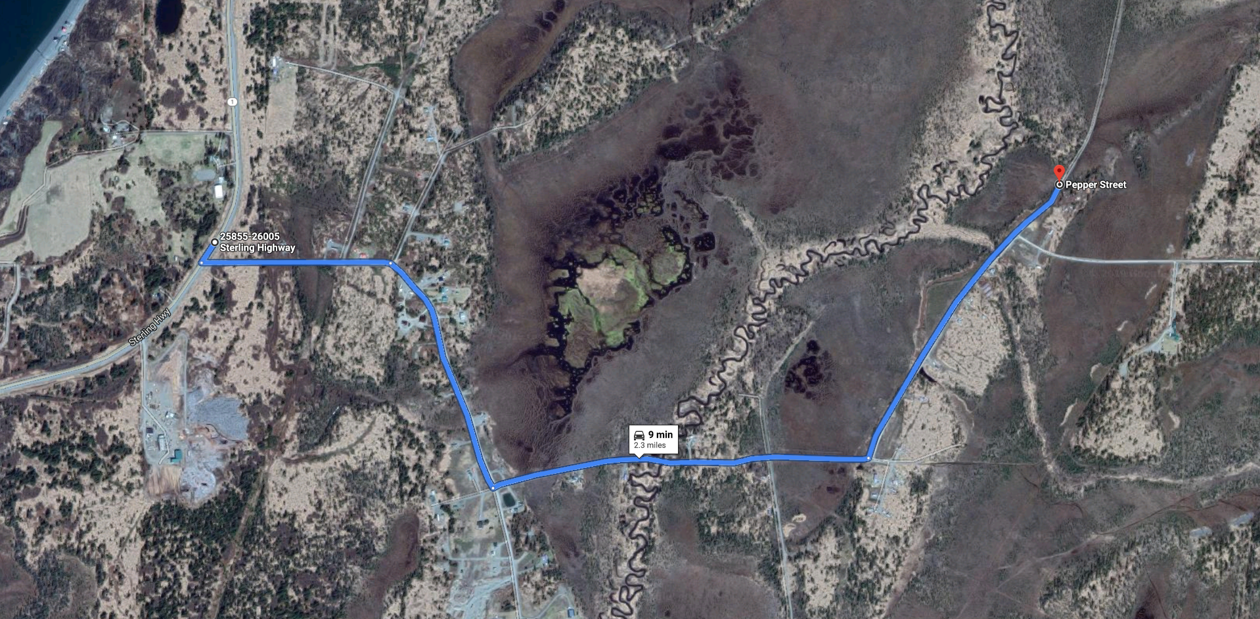
Suggested Meeting Point(s): Off the road at the KHLT sign
There is no parking lot but a small turnout that could accommodate three 12-15 passenger vans. Joel Cooper (KHLT) received permission from a neighboring landowner to park on his property during the Smithsonian Board Visit (July 2019); could be an option if more space is needed. If utilizing the bridge and creek for an activity, there is a small turnout that can accommodate three vehicles.

Site Vulnerabilities: there is no established trail at this site, and KHLT would like to keep it that way; therefore, participants should spread out as they walk to evenly distribute the impact of their footsteps and prevent the creation of a trail. DO NOT WALK IN SINGLE FILE.

Physical Exertion Requirements: walking on uneven ground including calf-high vegetation and springy moss (expect your feet to sink into the ground). Calf-height boots are sufficient during dry weather. Participants should be comfortable lifting their legs into a 90-degree angle.
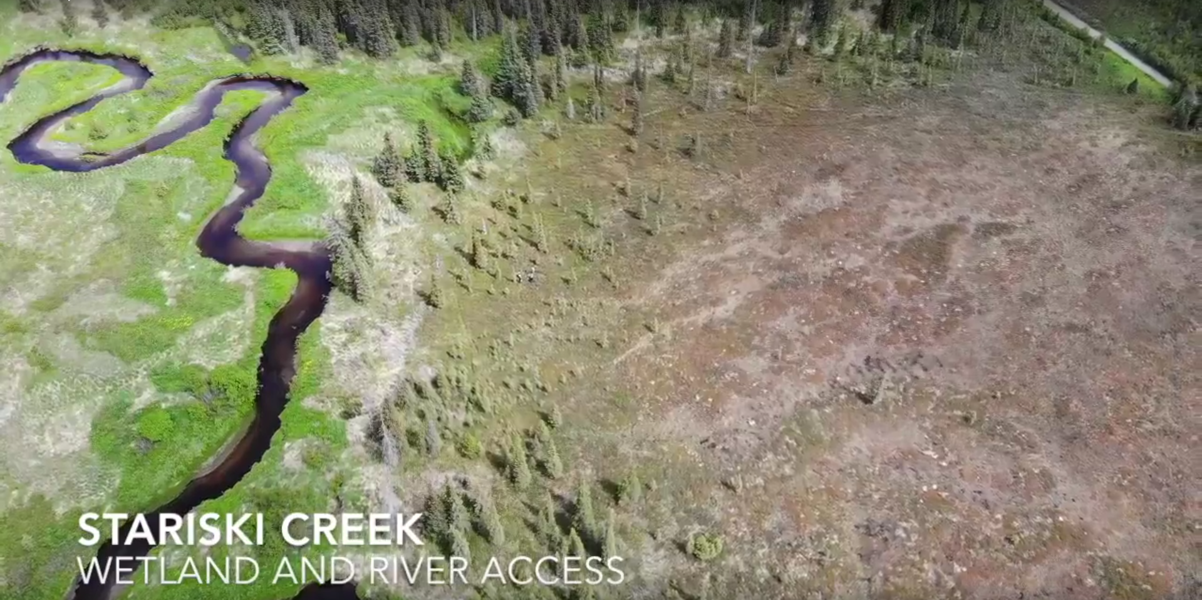
Still of drone footage captured by Jacob Argueta: Wetland access, bridge and creek access not pictured

Potential Engagement Activities: plant identification, soil coring, invertebrate identification, salmon capture/identification (creek)
**NOTE: Cannot electro fish at this site: seins before the Smithsonian Board Visit did not capture any fish

History of Place: See Kachemak Heritage Land Trust, Marie McCarty
Talk to KHLT about what they monitor on their properties

Past Projects: Smithsonian Board Visit (July 25, 2019) with 20 participants and 9 staff
Instructors: Dennis Whigham, Mark Rains, Coowe Walker
For more details see Coowe Walker or Syverine Bentz (contact information below)

NERR Priority Areas Addressed:
- Ecological functions that support ecosystem services in headwater streams
- Salmon systems are connected from headwaters to estuaries through key landscape support elements, including peat wetlands and groundwater functions
- There are a variety of opportunities for community engagement and decision-making based on stakeholder perspectives

Key Topic Areas & Messages:
- Peatland Plant Communities
  - Community diversity
  - Climate change effects (shifting plant communities due to drying)
  - Plant traditional used
  - Orchid/fungi relationships
- Peatland Wetland Functions
  - Salmon support: nutrients, baseflow, temperature control)
  - Geologic setting & fen history
  - Groundwater studies, lag times
  - Blue Carbon
  - Stakeholder blue carbon and groundwater site-based trainings
- Freshwater phase of Salmon Life History (at the creek)
  - Landscape support of streams and baby salmon
  - Conservation efforts
  - Macroinvertebrates as prey
  - Nutrient limited landscape and importance of Alder
  - Fish Need Land Too field trips
  - Before/after condition of mitigation property

Common Species: See species list in cross section below
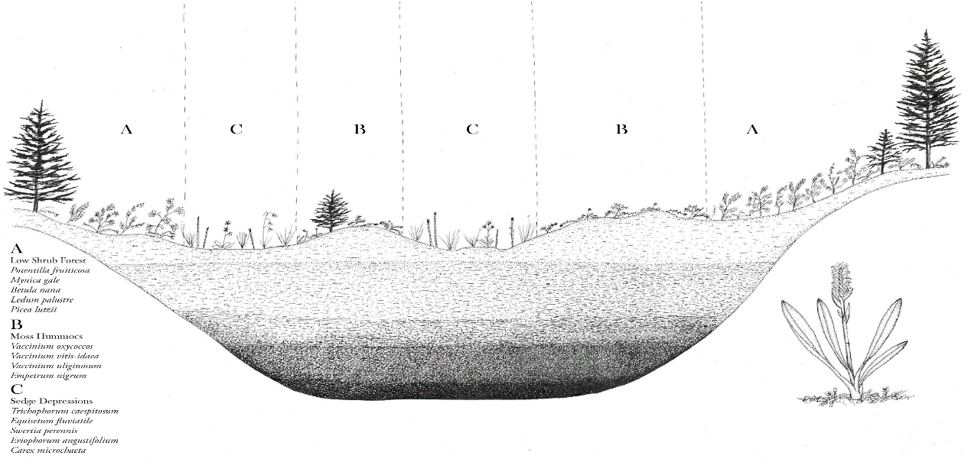
Cross section with plant community distribution and species list (art by Conrad Field)

Resources:
Blue Carbon field trip videos from 2018:
https://vimeo.com/282414784
Process Agenda for Smithsonian Board Visit (see Coowe Walker or Syverine Bentz)

